150116034_HW2.R

Garip

2020-05-22

# Enes Garip  
# 150116034  
  
###################################  
  
load(file = "Homework_2_50samples.rdata")  
rdata<-ex0717  
library(HistogramTools)  
  
###################################  
  
  
############ PART-A ###############  
  
sample_values=rdata$`Sample mean`  
  
RFHistogram<-hist(sample_values,freq = FALSE)

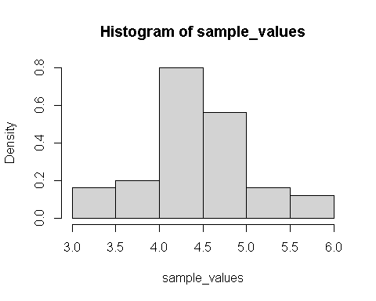

PlotRelativeFrequency(RFHistogram,col=blues9)

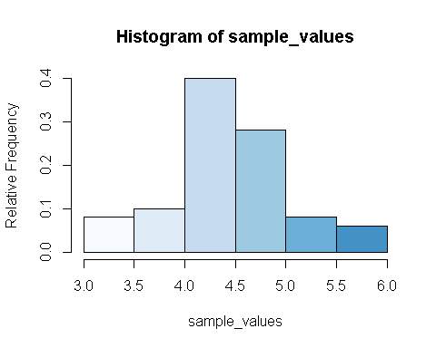

print("The distribution is mound-shaped distrubiton")

## [1] "The distribution is mound-shaped distrubiton"

############ PART-B ###############  
calcMeanOfSampleValues=mean(rdata$`Sample mean`)  
calcSDOfSampleValues=sd(rdata$`Sample mean`)  
  
print(calcMeanOfSampleValues)

## [1] 4.486

print(calcSDOfSampleValues)

## [1] 0.6230308

############ PART-C ###############  
  
theoreticalMean=4.4  
theoreticalSD=2.15/sqrt(10)  
  
differenceOfMeans=theoreticalMean-calcMeanOfSampleValues  
differenceOfSD=theoreticalSD-calcSDOfSampleValues  
  
print(differenceOfMeans)

## [1] -0.086

print(differenceOfSD)

## [1] 0.05685892

sprintf("The difference of means is %f and the value is very small so the theoretical mean is very close to the population mean",differenceOfMeans)

## [1] "The difference of means is -0.086000 and the value is very small so the theoretical mean is very close to the population mean"

sprintf("The difference of standard deviations is %f. The value is very small so the theoretical standard deviation is very close to population standard deviation.",differenceOfSD)

## [1] "The difference of standard deviations is 0.056859. The value is very small so the theoretical standard deviation is very close to population standard deviation."